Structural Equivalence

Based on Wasserman and Faust (1994) Chapter 9

ROLES & POSITIONS

W&F (pp. 347-356) provide a succinct history and overview of two core sociological concepts: social position (sets of actors with similar ties to others) and social role (systems of ties between actors or positions) in relation to network analysis. Figure 9.1 indicates the interconnections between role and positional analysis, which they investigate over several chapters. A key advance in the 1970s was the CONCOR algorithm, developed by Harrison White and his students, to identify a social network’s structurally equivalent actors. Several subsequent procedures have been incorporated into UCINET.

STRUCTURAL EQUIVALENCE

In Lorrain & White’s (1971) formal mathematical treatment, two actors have structural equivalence if they have identical ties to and from all the g-2 other actors in a digraph or nondirected graph. In matrix terms, both the row- and column-vectors of an equivalent pair have identical elements.

In a binary network, a structurally equivalent pair is indistinguishable when they exhibit exactly the same set of present and absent ties (0-1) with an identical set of third actors. In effect, one equivalent actor can substitute for another because the two relational patterns are impossible to tell apart.

In a valued graph, all equivalent actors’ ties must have the same magnitudes to & from third parties. For multiple networks, structural equivalence means that every pair has identical relational patterns with all third parties on every type of tie.

These criteria are as stringent as a clique definition. Even a single difference in the two sets of ties renders a pair of actors nonequivalent.

A structural position within a network consists of two or more actors that have identical relations to all outside actors/positions. We say that such members jointly occupy one position. (The actors occupying one position may differ in their ties among themselves, but the structural equivalence criterion disregards all relations inside a position.) If we know the pattern of external ties for any one member of a position, we therefore also know every other position member’s external relations (i.e., they’re identical). Hence, without any loss of information, a graph or sociomatrix of relations among network actors can be simplified (reduced) by representing the structurally equivalent actors as a single position (node) or equivalence class.

EX: Here’s a three-generation family tree, showing two types of relations, marital (==) and descent (|) ties. Three pairs of actors jointly occupy three structurally equivalent positions (inside the boxes). Why are the two parents not equivalent, unlike the two grandparental pairs and child dyad? Would the parents be structurally equivalent if all grandparents were not in this graph?

Gramma == Gramps
Nana == Pappy

Mommy == Daddy
Dick Jane

Structural equivalences within a graph are revealed by permuting (rearranging) the rows and columns of the corresponding sociomatrix, to show subsets of adjacent actors that have identical rows & column vector entries.

EX: The two s.e. positions {ABD} {CE} in this digraph are evident after permuting the 3rd and 4th rows-and-columns of the matrix. Note that ties within a position are not necessarily identical (all 0s or all 1s), but its members are s.e. because they have identical ties to all outsiders.

A
BB
D
C
E

BEFORE AFTER
A B C D E A B D C E
A 0 1 0 0 0 A 0 1 0 0 0
B 1 0 0 0 0 B 1 0 0 0 0
C 1 1 0 1 0 D 0 1 0 0 0
D 0 1 0 0 0 C 1 1 1 0 0
E 1 1 0 1 0 E 1 1 1 0 0
MEASURES of STRUCTURAL EQUIVALENCE

Because the structural equivalence requirement of perfectly identical ties seldom occurs in real social data, analysts typically relax this criterion by seeking to identify subsets of “approximately structurally equivalent” actors. That is, some differences in the patterns of a pair’s ties to third parties are accepted. Several continuous s.e. measures can be computed on pairs of rows-and-columns in a sociomatrix. Euclidean distance and the correlation coefficient are two popular distance metrics.

Path distance seems like a plausible distance measure, but it has a major problem. In geometry and geography, the distance from actor i to actor j equals the distance from j to i. However, as network analysts, we know that digraph distances are often asymmetrical. For example, one member of a dyad may reachable by the second member using a geodesic with a certain path length, but the second member by be reachable by the first member through a geodesic with a longer or shorter path length (or may not reachable at all). How does differential actor-to-actor path distance limit graphic and algebraic analyses of structural equivalence? If we were to force each dyad’s two geodesics to be identical to measure social distances, how badly might we distort theoretical notions of structurally equivalent network ties?

Euclidean distance: Use matrix data to calculate the distance between actors i and j (and vice versa) using their vectors of ties sent-to and received-from the g-2 other actors in the network, excluding self-ties and the pair’s mutual ties (k ≠ i ≠ j):

$$d_{\text{ij}}=\sqrt{\sum_{k=1}^{g−2}{[(x_{\text{ik}}−x_{\text{jk}})^{2}+(x_{\text{ki}}−x_{\text{kj}})^{2}]}}$$

Ties may be binary, signed, or valued. Larger numbers indicate greater distance, while d_{ij} = 0 indicates the two actors are exactly s.e.; why?

For multiple networks of distinct relational contents, just calculate the Euclidean distances for each of the R sociomatrices and sum them before extracting the square root.

A symmetrical matrix of pairwise Euclidean distances can be analyzed, as described below, to determine which subsets of actors are sufficiently close to be considered joint occupants of the same structurally equivalent positions. This matrix can also be analyzed by spatial plotting or mapping routines to display visually the distant/proximate locations among actors in a multidimensional social space.

Correlation coefficient: Apply Pearson’s product-moment correlation (r_{ij}) to pairs of row-and-column vectors. A perfect r=1.00 indicates identical ties to all third parties.

EX: Here are both s.e. measures applied to the permuted matrix above:

Euclidean Correlations
A B C D E A B D C E
A 0 0 0 1 1 A 1.0 1.0 1.0 0.5 0.5

B 0 0 1 1 1 B 1.0 1.0 0.0 0.5 0.5
C 0 1 0 1 1 D 1.0 0.0 1.0 0.5 0.5
D 1 1 1 0 0 C 0.5 0.5 0.5 1.0 1.0
E 1 1 1 0 0 E 0.5 0.5 0.5 1.0 1.0

The UCINET distance programs are located in the “Tools” dropbox (“Dissimilarities“ for Euclidean; “Similarities” for correlations). But, they allow calculations only for rows or for columns but not for both. (Thus, UCINET requires distance to be a symmetric relationship. My analyses above required a series of computations: transposing, extracting, stacking, importing, and distance calculations on the columns of a 10x5 matrix). Fortunately, as discussed below, CONCOR does allow a matrix and its transpose to be analyzed together.

Other structural equivalence measures include the simple match coefficient and a measure of ordinal association (W&F 370-371), as well as a plethora of measures popularized by biological taxonomists and cluster analysts, including the Manhattan (city-block), Minkowski, Sokal & Sneath, and Jaccard coefficients. These and other distance/proximity measures are implemented in SPSS hierarchical cluster analysis, which will write output matrices that you can then read into UCINET. W&F (371-375) compare the advantages and drawbacks of some s.e. measures.

REPRESENTING NETWORK POSITIONS

Visual displays of matrices, dendogram or tree diagrams, and spatial maps communicate Gestalt impressions of the distances among structurally equivalent positions and/or actors.

CONCOR

Popularized by White et al. for blockmodel analysis, the CONCOR (CONvergence of iterated CORrelations) routine repeatedly correlates the row & column vectors of one or more sociomatrices until all entries become either +1 or –1. This pattern is the basis for an initial partition (split) into two structurally equivalent submatrices (“blocks” see W&F Chapter 10), which may contain differing numbers of actors. Subsequent bifurcations of these submatrices continue until every actor occupies a unique (solo) position. An analyst must decide which level of split to report, typically by using her substantive knowledge about the network. UCINET reports CONCOR results in a permuted subdivided matrix, a reduced density matrix, and a dendogram showing the sequence of partitions – or agglomerations if viewed left to right. (Are you a “lumper” or a “splitter”?) UCINET’s CONCOR is located in the dropbox “Networks/Roles & Positions/Structural”.

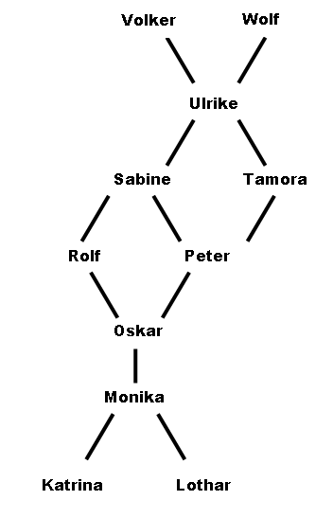 | Here’s the four-block partition of nondirected binary ties in a “German Network” (courtesy Ulrich Brandes):  K L M U P R S O T V W  -----------------------------  1 Katrina | 1 | | | |  2 Lothar | 1 | | | |  3 Monika | 1 1 | | 1 | |  -------------------------------  9 Ulrike | | | 1 | 1 1 1 |  5 Peter | | | 1 1 | 1 |  6 Rolf | | | 1 1 | |  -------------------------------  7 Sabine | | 1 1 1 | | |  4 Oskar | 1 | 1 1 | | |  -------------------------------  8 Tamora | | 1 1 | | |  10 Volker | | 1 | | |  11 Wolf | | 1 | | |  ------------------------------

Observe that some densities within and between positions differ from the 0.0 or 1.0 levels required under strict structural equivalence. The CONCOR dendogram reveals a simple differentiation: the German Network splits into four positions that have no subpositions (alternatively, each actor joins one of four positions, which then all merge simultaneously at the complete-network level).

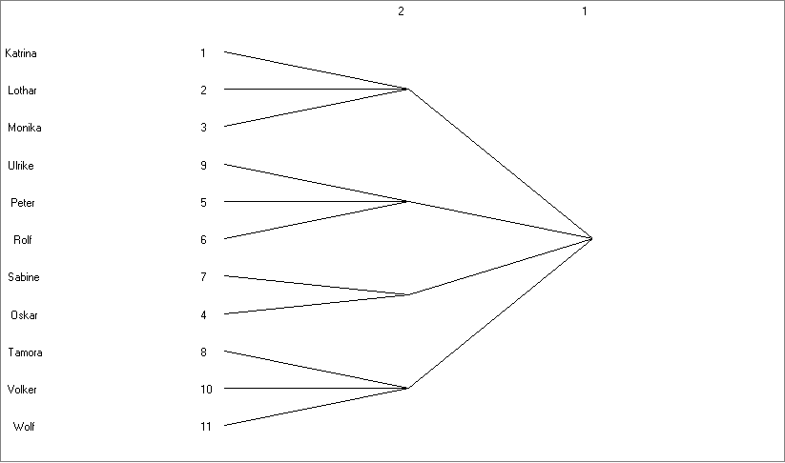

HIERARCHICAL CLUSTERING

Another method for identifying approximate structurally equivalent positions is to agglomerate (lump together) actors using a hierarchical cluster analysis of the matrix of Euclidean, correlational, or other distance measures. Unlike CONCOR’s two-splits-at-a-time, clustering permits actors to join existing positions in diverse sequences. The UCINET program is located in dropbox “Tools/Cluster/Hierarchical”.

EX: First I computed and saved a Euclidean distance matrix of undirected German ties. Then a hierarchical cluster analysis of that matrix yielded this dendogram:

K L M O R P S T U V W
a o o s o e a a l o o
t t n k l t b m r l l
Level r h i a f e i o i k f
----- - - - - - - - - - - -
2 XXXXXXX . . XXXXXXXXX
1 XXXXXXXXX XXXXXXXXXXX

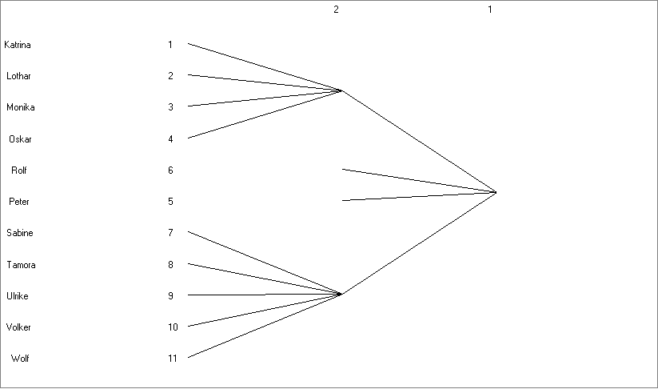

This method reveals two multi-actor positions and two solo-actor positions (singletons). One possible reason for the different results may be that I used correlations for CONCOR and Euclidean distances for the hierarchical clustering.

SPATIAL REPRESENTATIONS

Multidimensional scaling (MDS) comprises a set of methods for plotting or mapping the proximities between network actors or positions, using a symmetric matrix of pairwise similarities (e.g., correlations) or dissimilarities (e.g., Euclidean distances). An analyst controls the number of dimensions for a solution. (Although only two or three X-Y coordinates can be plotted on a two-dimensional plane, such as a article page). A stress value summarizes how closely the n-dimensional coordinates reproduce the input matrix. In my experience, a stress lower than 0.10 reflects a relatively “good fit.”

I like to combine MDS with a hierarchical cluster analysis of the same distance matrix. After obtaining the coordinates that determine the spatial locations of every actor, I use Word graphics to draw a contiguity line around all position members. With some luck, the clusters will be distinct and succinct, represented as tight circles and ovals; without luck, the results may be meandering amoebas with tangled pseudopods. The UCINET program is in dropbox “Tools/MDS/Non-metric”. In the entry “Similarities or Dissimilarities” decide whether the input data are nearness or farness measures, respectively. In entry “Starting Configuration” select Metric.

Once again, the German Network in MDS of Euclidean distances (stress = 0.033):

