1. (A)Weight에 따라 number of crackers eaten에 차이가 있을 것이다

2. (B)Fullness에 따라 number of crackers eaten에 차이가 있을 것이다

3. Fullness와 Weight의 상호작용에 따라 number of crackers eaten에 차이가 있을 것이다(B는 A와 상호의존적인 상태이다.)

a=0.05

df (total):80-1=79

df (within):19+19+19+19=76

df (between）:4-1=3

df (a）:2-1=1

df（b）:2-1=1

df (A+B)=3-1-1=1

SS（total）:31836-(1440)^2/80=5916

SS（within）:1540+1270+1320+1266=5396

SS（between）:5916-5396=520

SS（a）:((740)^2/40)+((700^2)/40)-((1440)^2/80)=20

SS（b）:(780)^2/40+(660)^2/40-(1440)^2/80=180

SS（a+b）:520-20-180=350

MS

MSa:20/1=20

MSb:180/1=180

MS（a+b）:350/1=350

MS（within）:5396/76=71

F-ratio

Fa:(1,76)=20/71=0.2817 < F-ratio≈3.98

Fb:(1,76)=180/71=2.5352 <F-ratioo≈3.98

F（a+b）:(1,76)=350/71=4.9296>F-ratioo≈3.98

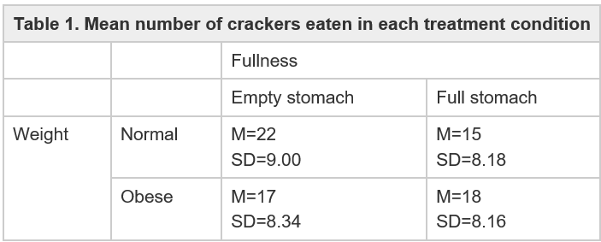

|  |  |  |  |  |
| --- | --- | --- | --- | --- |
| **Table 2. Result** | | | | |
| Source | SS | df | MS | F |
| Between treatment | 520 | 3 | - | - |
| -Factor A (weight) | 20 | 1 | 20 | 20/76(0.28) |
| -Factor B (fullness) | 180 | 1 | 180 | 180/76(2.53) |
| -A x B interaction | 350 | 1 | 350 | 350/76(4.9296) |
| Within treatment | 5396 | 76 | 71 | - |
| Total | 5916 | 79 | - | - |
| Weight x fullness factorial design | | | | |

B는 A와 상호의존적인 상태이다.