1. (A)Weight에 따라 number of crackers eaten에 차이가 있을 것이다
2. (B)Fullness에 따라 number of crackers eaten에 차이가 있을 것이다
3. Fullness와 Weight의 상호작용에 따라 number of crackers eaten에 차이가 있을 것이다(B는 A와 상호의존적인 상태이다.)
a=0.05

df (total):80-1=79
df (within):19+19+19+19=76
df (between）:4-1=3
df (a）:2-1=1
df（b）:2-1=1
df (A+B)=3-1-1=1
SS（total）:31836-(1440)^2/80=5916
SS（within）:1540+1270+1320+1266=5396
SS（between）:5916-5396=520
SS（a）:((740)^2/40)+((700^2)/40)-((1440)^2/80)=20
SS（b）:(780)^2/40+(660)^2/40-(1440)^2/80=180
SS（a+b）:520-20-180=350
MS
MSa:20/1=20
MSb:180/1=180
MS（a+b）:350/1=350
MS（within）:5396/76=71
F-ratio
Fa:(1,76)=20/71=0.2817 < F-ratio≈3.98
Fb:(1,76)=180/71=2.5352 <F-ratioo≈3.98
F（a+b）:(1,76)=350/71=4.9296>F-ratioo≈3.98

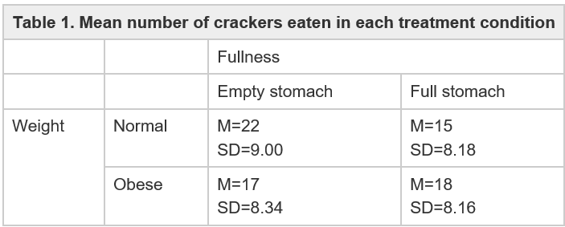
Table 2. Result
Source | SS | df | MS | F
Between treatment | 520 | 3 | - | -
-Factor A (weight) | 20 | 1 | 20 | 20/76(0.28)
-Factor B (fullness) | 180 | 1 | 180 | 180/76(2.53)
-A x B interaction | 350 | 1 | 350 | 350/76(4.9296)
Within treatment | 5396 | 76 | 71 | -
Total | 5916 | 79 | - | -
Weight x fullness factorial design
B는 A와 상호의존적인 상태이다.

